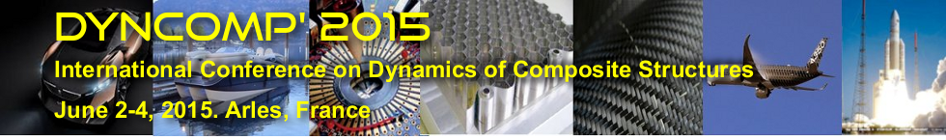

DELAMINATION AND DEBONDING PREDICTIONS FOR TYRE IMPACT ONTO COMPOSITE A/C COMPONENTS

Dr Michel Fouinneteau¹

¹ Airbus Operation S.A.S, 316 route de Bayonne, 31060 Toulouse Cedex 09, France

Email: Michel.fouinneteau@airbus.com

ABSTRACT

Tire debris impact is a recurring event in the aircraft lifetime, which can potentially affect its structural integrity. In this work, delamination and debonding failure mechanisms are investigated in order to define a robust modeling method applicable at aircraft subcomponent level.
A standard cohesive element available in the explicit code Abaqus is used to represent ply interface and bondline failure. Due to finite element model size limitation driven by industrial operability, relatively large cohesive element size was used. A calibration exercise based on an existing knock-down method was conducted to insure correlation at coupon levels such as DCB, ENF and MMB.
The calibrated methodology confidence was assessed upon three different levels of structural complexity ranging from skin panel to wing box lower skin based on Airbus building block approach philosophy.
Numerical predictions for delaminated and debonded areas have shown a satisfying level of correlation to test in terms of predicted damage and overall structural behavior. Such methodology can be used to have a general assessment on post-impact structure integrity.

